1. **List the access method on Memory?**

* **Direct access:** involves as a shared read/write mechanism.
* **Sequential access:** Access must be made in a specific linear sequence.
* **Random access:** any location can be selected at random and directly accessed.
* **Associative:** a word is retrieved based on a portion of its contents rather than its address

**2. Write notes about “Word” on Memory?**

* A word is defined in terms of the size of the databus, the amount of information that can be transferred in one operation.

**OR**

* Word size is also often defined as the native data size of integers in a processor ( the integer register size). This would typically be 64 bits in a modern computer.

**OR**

* It's sometimes neither of those, and is defined seemingly arbitrarily, based on compatibility or other factors. For example, x86 defines a word as 16bit despite modern CPU's being 64bit capable and having a 128 bit memory access. This is because the original implementation of x86 the (i8086) had a 16 bit word size based on the databus and ALU width. To preserve compatibility, the x86 WORD is still defined as 16 bits, 32 bits being a DWORD and 64 bits being a QWORD

**3. Write notes about Memory hierarchy?**

**The design constraints on computer can be summed up by three questions:**

* + **How much**? : Is somewhat open ended. If the capacity is there, applications will be developed to use it.
  + **How fast**? : To achieve greatest performance with processor without making it waiting.
  + **How expensive**? : The cost of memory must be reasonable to other components.

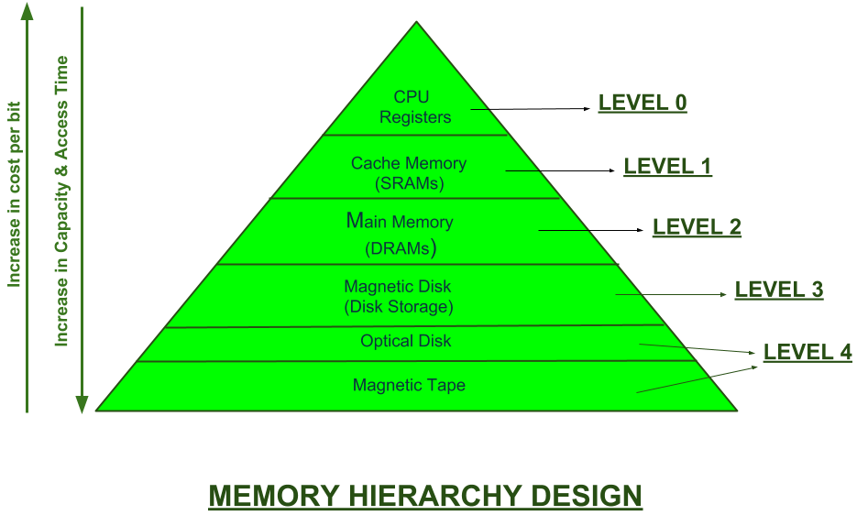

This Memory Hierarchy Design is divided into 2 main types:

1. **External Memory or Secondary Memory –**  
   Comprising of Magnetic Disk, Optical Disk, Magnetic Tape i.e. peripheral storage devices which are accessible by the processor via I/O Module.
2. **Internal Memory or Primary Memory –**  
   Comprising of Main Memory, Cache Memory & CPU registers. This is directly accessible by the processor.

We can infer the following characteristics of Memory Hierarchy Design from above figure:

1. **Increasing Capacity**
2. **Increasing Access Time**
3. **Increasing Performance**
4. **Decreasing Cost per bit**